Step 0 Source: Intake Result: Filing Status, Dependency
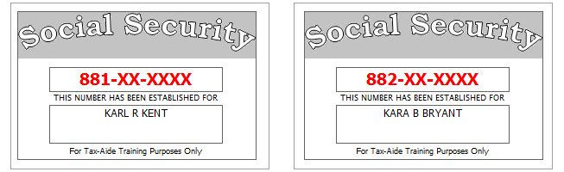
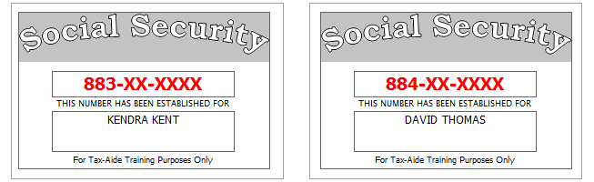
Karl and Kara have been married for several years and are currently full-time residents of Denville, New Jersey (Morris County). They want to file both a federal and a state return.
Their daughter, Kendra, is a full-time student classified as a junior at her college.
No one else can claim Kendra or Dave as a dependent.
Carmen Bryant is Kara’s older sister who is totally and permanently disabled. Carmen lived with the Kents all year and was fully supported by them. No one else can claim her as a dependent and she earned no income.
Karl and Kara provided 100% of the support for both Kendra and Dave.
Reference: 4012 Tab A, B, C
Tool: IRS Interactive Tax Assistant (link on Preparer page)
Tool: AARP Resource Tool for Counselors (Laminated Flow Chart
Tool: TP4F Qualifying Child/Qualifying Relative Flowchart Tool (link on Preparer page)
Tool: Dependent Calculator (link on Preparer page)
Step 1a Source: Intake Part I, II, VII TWO Screen: Main Info
Use the Filing Status and Dependency Status from Step 0
Refund Monitor
AGI | Refund | NJ 39 | NJ 56/66 | Notes
Hint: If carry-forward is offered when you create the return, please do NOT accept – Create a new return instead
Hint: If TWO says there is an existing deleted return, do NOT accept – Create a new return instead
Hint: Use all names from SS Cards (NOT Intake Sheet)
BP: Do not enter SP last name if same as TP (see field help)
Hint: Presidential Election Campaign from Intake Sheet, page 3, part VII, line 1
BP: List dependents from youngest to oldest
Hint: Use Code 1 (or 2) if dependent is “qualifying child” per IRS rules; use code 3 if dependent is “qualifying relative”
Hint: Check EIC box for all dependents who might qualify for EIC
Hint: Ctrl-E to go to next red field
Hint: Don’t worry about RTN / DAN for direct deposit at this point.
Hint: TP/SP PIN – any 5 digits (except 00000)
Check: Main Info should be green in tree at this point
Hint: Various other worksheets will become red in the tree as we go along. As a general rule, you should NOT worry about red worksheets until you have finished entering data from all documents and notes
Step 1b Source: Intake Part I TWO Screen: NJ 1040 Pg1
[no notes]
Reference: NJ Special Handling p5
Tool: NJ Municipality Code Lookup Tool (link on Preparer page)
Tool: NJ 1040 Instructions – Municipality Code Table
Tool: TWO State Help
Refund Monitor
AGI | Refund | NJ 39 | NJ 56/66 | Notes
 |  |  |  | Hint: Use NJ Municipality Code Lookup Tool
Step 1c Source: Intake Part I, II TWO Screen: NJ 1040 Pg 2
Kendra is a full-time student classified as a junior at her college.
All dependents have health insurance (as of the time the return is filed)
Kara would like $1 to go to the Gubernatorial Election Campaign Fund, while Karl does not wish to contribute to the Gubernatorial Fund.
Reference: NJ Special Handling p5
Refund Monitor
AGI | Refund | NJ 39 | NJ 56/66 | Notes
Hint: Is there a dependent (under age 22) attending college?
Hint: Health care coverage – see Notes
Hint: Gubernatorial Elections Fund – see Notes
Step 1d Source: Intake Part VII TWO Screen: Prep Use
[no notes]
Refund Monitor
AGI | Refund | NJ 39 | NJ 56/66 | Notes
Hint: 11 & 12: Enter from page 3, part VII, line 4 & 5
13: Your initials
14: Leave empty and red for QR initials
Hint: The Prep Use worksheet will stay red until Quality Review is done and QR initials are entered

Step 2 Source: W-2 TWO Screen: W2 (SP)
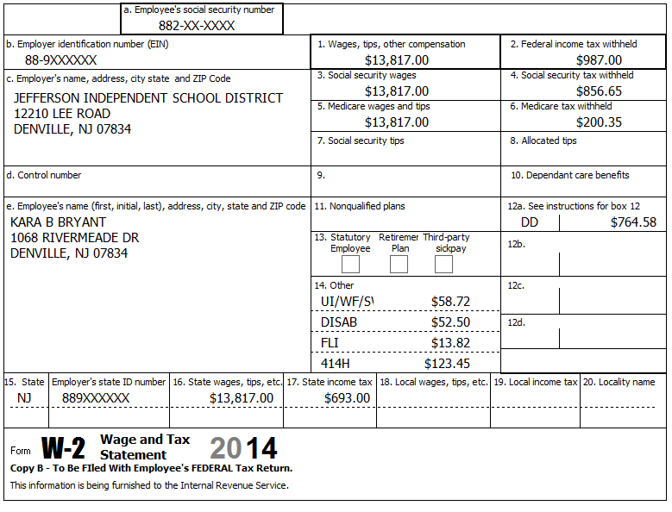
Reference: 4012 D-6
Reference: NJ Special Handling p1
Refund Monitor
AGI | Refund | NJ 39 | NJ 56/66 | Notes
13,817 | 5,292 | 5,317 | 1,354 | Hint: If the name and address of the employer come up after inputting the Employer Identification Number, check that the information is correct and take the red out of the fields (Ctrl-Space or F3 key)  Hint: If the checkbox for “Please verify the Federal withholding, …” turns red, double check your entries in Box 1 & 2, then check the box  Hint: Box 14 NJ codes may not match template – use template codes  Check: Sch A, line 5a=819  Check: NJ 2450 SP, line 2, A=59, B=53, C=14
Step 3a Source: W-2 TWO Screen: W2 (TP)
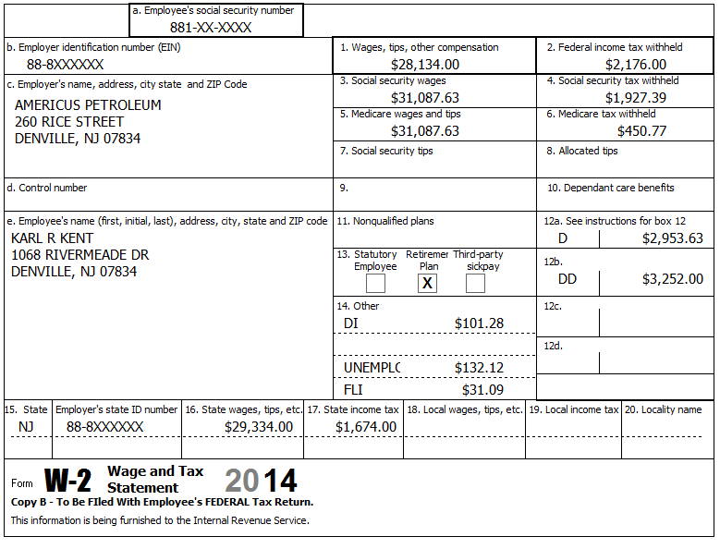
DI PP# 102030456
Karl’s W-2 / final pay stub had extra detail showing $1,200 for a Section 125 (pre-tax federal / after-tax NJ) Dental plan.
Reference: 4012 D-6
Reference: NJ Special Handling p1, p3
Refund Monitor
AGI | Refund | NJ 39 | NJ 56/66 | Notes
41,951 | 3,614 | 34,651 | 1,893 | Hint: Use + next to existing W2 in tree (or Add button above tree, or link from 1040 line 8) to add another W2  Hint: Enter the amount in box 12 before attempting to correct the amounts in boxes 3,4,5,6  Hint: See NJ Special Handling for how to deal with DI PP#  Hint: You will need to check box “Check to take calculations off of line 16…” before you can correct the box 16 amount  Check: Sch A, line 5a=2,656  BP: Do NOT do anything with Sec 125 insurance now – need to wait until NJ income is finalized.  BP: Handle NJ 2450 now (next sub-step)

Step 3b Source: W-2 TWO Screen: NJ 2450 TP
[no notes]
Reference: NJ Special Handling p7
Refund Monitor
AGI | Refund | NJ 39 | NJ 56/66 | Notes
41,951 | 3,614 | 34,651 | 1,893 | Hint: See NJ Special Handling for how to deal with DI PP#  BP: Use Scratch Pad linked to Line 1a, Col B to document source of DI PP# amount  Check: NJ 2450 TP, line 2, A=132, B=101, C=31
Step 4 Source: Notes TWO Screen: Sch B
Last year’s return showed a seller-financed mortgage on Sch B.
Karl is collecting payments on a seller-financed mortgage. The purchaser is Charles Campbell (SSN 885-XX-XXXX), 1523 North Curry Rd, Denville, NJ 07834. Last year Karl received $2,782.15 interest on that loan.
Neither Karl nor Kara had an interest in a financial account in a foreign country and have never received distributions from or transferred funds to a foreign trust.
Reference: 4012 D-8
Refund Monitor
AGI | Refund | NJ 39 | NJ 56/66 | Notes
44,733 | 3,025 | 37,433 | 1,782 | Hint: Look on Preparer Page Lookup Tool to see where to enter this  Hint: Don’t forget the questions in Part III
Step 5 Source: 1099-INT TWO Screen: Interest Stmt
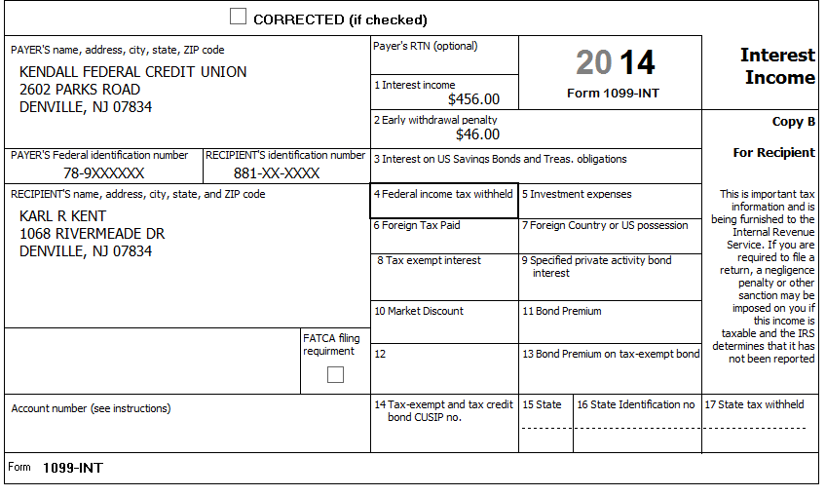
Reference: 4012 D-9
Refund Monitor
AGI | Refund | NJ 39 | NJ 56/66 | Notes
45,143 | 2,985 | 37,843 | 1,775 | Hint: Interest Stmt worksheet is under Sch B in the tree

Step 6 Source: 1099-INT TWO Screen: Interest Stmt
ZYX Investments | End of Year Tax Information Statement  Account 203040506 | Statement Date: 01-30-2015  Page 1 of 3 | 2014
123 Main Street  P.O. Box 07978-123  Pluckemin, NJ 07978  PAYER’S Federal ID No: 78-7XXXXXX | Karl R. Kent  1068 Rivermeade Dr  Denville, NJ 07834  RECIPIENT’S ID No: 881-XX-XXXX | Your Broker:  SERGE BRONSKI  888-555-5555  sbronski@rjones.com

Interest Income – 1099-INT – Reported to IRS
1 | Interest Income (not included in line 3) | 123.00
2 | Early withdrawal penalty | 0.00
3 | Interest on US Savings Bonds & Treasury obligations | 2,455.00
4 | Federal Income tax withheld | 245.00
5 | Investment expenses | 0.00
6 | Foreign tax paid | 0.00
7 | Foreign country or US possession
8 | Tax-exempt interest (includes line 9) | 337.85
9 | Specified private activity bond interest (AMT) | 0.00
10 | Tax-exempt bond CUSIP numbers (see instructions)
11 | State
12 | State ID numbers
13 | State tax withheld | 0.00
 | FATCA filing requirement | NO

Interest Detail (only summary 1099-INT reported to IRS)
Date | 1 Interest Income | 2 Early withdrawal penalty | 3 Interest on US Savings Bonds | 4 Federal withholding | 8 Tax-exempt interest
MooFoo Mutual Fund
12-30-2014 | 123.00 | 0.00 | 2,455.00 | 245.00 | 0.00
New Jersey Muni Bond
12-30-2014 | 0.00 | 0.00 | 0.00 | 0.00 | 148.63
Georgia Muni Bond
12-30-2014 | 0.00 | 0.00 | 0.00 | 0.00 | 189.22
Totals: | 123.00 | 0.00 | 2,455.00 | 245.00 | 337.85

Money from U.S. Savings Bonds was used for house repairs.
Reference: 4012 D-9
Reference: NJ Special Handling p1, p2
Refund Monitor
AGI | Refund | NJ 39 | NJ 56/66 | Notes
47,721 | 2,970 | 38,155 | 1,769 | Hint: Easier to check if use separate lines for each type of interest  Check: Fed 1040, line 8a=5,816, 8b=338  Check: NJ 1040, line 15a=3,504, 15b=2,604

Step 7a Source: 1099-DIV TWO Screen: Dividend Stmt
ZYX Investments | End of Year Tax Information Statement  Account 203040506 | Statement Date: 01-30-2015  Page 2 of 3 | 2014
123 Main Street  P.O. Box 07978-123  Pluckemin, NJ 07978  PAYER’S Federal ID No: 78-7XXXXXX | Karl R. Kent  1068 Rivermeade Dr  Denville, NJ 07834  RECIPIENT’S ID No: 881-XX-XXXX | Your Broker:  SERGE BRONSKI  888-555-5555  sbronski@rjones.com

Dividends and Distributions – 1099-DIV – Reported to IRS
1a | Total ordinary dividends (includes line 1b) | 231.86
1b | Qualified dividends | 125.25
2a | Total capital gain distributions (includes lines 2b, 2c, 2d) | 68.75
2b | Unrecaptured Section 1250 gain | 0.00
2c | Section 1202 gain | 0.00
2d | Collectibles (28%) gain | 0.00
3 | Nondividend distributions | 2.44
4 | Federal Income tax withheld | 0.00
5 | Investment expenses | 0.00
6 | Foreign tax paid | 3.75
7 | Foreign country or US passion
8 | Cash liquidation distributions | 0.00
9 | Noncash liquidation distributions | 0.00
10 | Exempt-interest dividends (includes line 11) | 200.00
11 | Specified private activity bond interest dividends (AMT) | 22.00
12 | State
13 | State ID number
14 | State tax withheld | 0.00
 | FATCA filing requirement | NO

Dividend Detail (only summary 1099-DIV reported to IRS)
Date | 1a Ordinary dividends | 1b Qualified dividends | 2a Capital gains | 3 Nondiv. Dists. | 4 Federal w/h | 6 Foreign tax paid | 10 Exempt Interest | 11 Sp. PAB
MooFoo Mutual Fund
12-30-2014 | 231.86 | 125.25 | 68.75 | 2.44 | 0.00 | 3.75 | 0.00 | 0.00
Select US General Fund
12-30-2014 | 0.00 | 0.00 | 0.00 | 0.00 | 0.00 | 0.00 | 100.00 | 0.00
Select NJ Qualified Fund
12-30-2014 | 0.00 | 0.00 | 0.00 | 0.00 | 0.00 | 0.00 | 100.00 | 22.00
Totals: | 231.86 | 125.25 | 68.75 | 2.44 | 0.00 | 3.75 | 200.00 | 22.00

Exempt-interest dividends by Area | Select US General Fund | Select NJ Qualified Fund
US Federal, Possessions, Territories obligations | 30.0% | 20.0%
New Jersey State and Local obligations | 10.0% | 65.0%
All Other State and Local obligations | 60.0% | 15.0%

Reference: 4012 D-11
Reference: NJ Special Handling p2
Refund Monitor
AGI | Refund | NJ 39 | NJ 56/66 | Notes
48,022 | 2,960 | 38,541 | 1,763 | Hint: Dividend Stmt worksheet is under Sch B in the tree  Check: Fed 1040, line 8a=5,816, 8b=538  Check: NJ 1040, line 15a=3,504, 15b=2,719  BP: Handle 1116 (Foreign tax) now (next sub-step)
Step 7b Source: 1099-DIV TWO Screen: 1116 Pg 1
[no Notes]
Reference: 4012 G-2
Refund Monitor
AGI | Refund | NJ 39 | NJ 56/66 | Notes
48,022 | 2,964 | 38,541 | 1,763 | Hint: May need to manually add 1116 Pg 1  Hint: Do NOT worry about red stuff on form 1116 below “Simplified Limitation Election”
Step 8a Source: Notes TWO Screen: 1040 Pg 1
Looking at their prior year state return, you see that they had a $437 state income tax refund. So you check their prior year federal return and determine that they itemized deductions (and used state income taxes (5a) instead of state sales taxes (5b)).
The Kents remember receiving a refund check, but don’t remember if the amount is correct, so you use the NJ online refund query tool to check on their prior year state income tax refund amount. It shows an amount consistent with the refund amount on their prior year NJ return.
Reference: 4012 D-12
Reference: NJ Special Handling p2
Tool: NJ Form 1099-G Inquiry (Refund)
Refund Monitor
AGI | Refund | NJ 39 | NJ 56/66 | Notes
48,309 | 2,934 | 38,541 | 1,763 | Hint: See NJ Special Handling: State Income Tax Refunds  Hint: 1040, Line 10 amount will be calculated on St Tax Refund worksheet  Hint: When added, the St Tax Refund worksheet is inserted in tree between Main Info and Cap Gn Wkt
Step 8b Source: Notes TWO Screen: St Tax Refund
Their prior year federal return shows that the amount of state income taxes on Schedule A, line 5a was $1,320 and the amount of state sales tax on line 5b was $955.00. Their total itemized deductions were $13,687. Their taxable income was $39,544.
Reference: 4012 D-12
Reference: NJ Special Handling p2
Tool: Prior year Sch A Sales Tax Table (link on Preparer page)
Refund Monitor
AGI | Refund | NJ 39 | NJ 56/66 | Notes
48,309 | 2,934 | 38,541 | 1,763 | Hint: Karl was over 65 last year  Check: St Tax Refund, line 9 = 13,400

Step 9a Source: Notes TWO Screen: Sch C Pg 1
Kara has a small business, which she operates out of her home, typing medical transcripts. She received income reported on a 1099-MISC as well as cash income.
She uses the Cash accounting method. She has materially participated in the operation of the business for several years. She made no payments that would have required filing Form(s) 1099. This business is not an LLC.
Reference: 4012 D-14
Tool: NAICS Search Tool (link on Preparer page)
Tool: TWO Help
Tool: 1040 Instructions, Sch C Business Codes table
Refund Monitor
AGI | Refund | NJ 39 | NJ 56/66 | Notes
48,309 | 2,934 | 38,541 | 1,763 | Hint: Use NAICS Search Tool to lookup box B Business Code (enter keyword “typing” or “transcription” in this case)  Hint: Use field help to determine if you need to enter anything in boxes C, D, or E  Hint: It is ok to link both the 1099-MISC and a Scratch Pad (for cash) to line 1  Hint: It is easier to enter expenses on Sch C Pg 2, Part V than to figure out proper use of lines in Sch C Pg 1, Part II
Step 9b Source: 1099-MISC TWO Screen: 1099 MISC
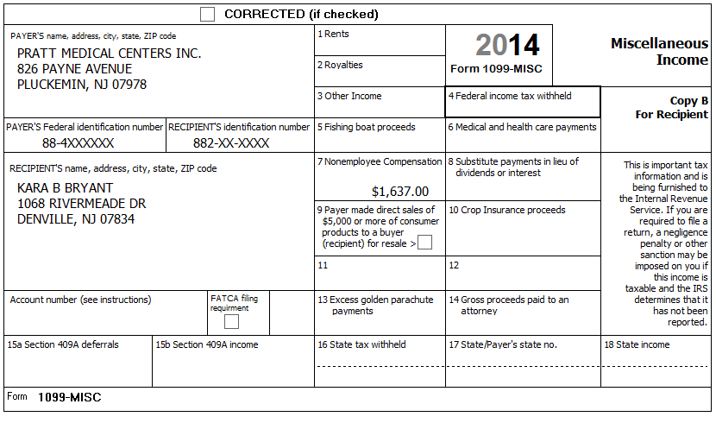
Reference: 4012 D-14
Refund Monitor
AGI | Refund | NJ 39 | NJ 56/66 | Notes
49,830 | 2,553 | 40,178 | 1,734 | Hint: Link from Sch C Pg 1, line 1 to a new 1099 MISC
Step 9c Source: Notes TWO Screen: Scratch Pad*
* Scratch Pad attached to Sch C, Line 1
In addition to the amount reported on Form 1099-MISC, she also received $1,082 during the year from various other doctors for this service
Reference: 4012 D-14
Refund Monitor
AGI | Refund | NJ 39 | NJ 56/66 | Notes
50,836 | 2,300 | 41,260 | 1,715 | Hint: Link from Sch C Pg 1, line 1 to a new Scratch Pad
Step 9d Source: Notes TWO Screen: Sch C Pg 2
Kara used her second car for picking up and delivering the typing jobs. She maintained a written record of mileage, reporting 35 business miles per month and 10,000 total other miles. She bought the car and started using it for business on January 2, 2007. Kara has another car available for personal use.
Her expenses included $45.00 for paper and $67.50 for a printer cartridge.
Reference: 4012 D-15
Refund Monitor
AGI | Refund | NJ 39 | NJ 56/66 | Notes
50,512 | 2,378 | 40,912 | 1,721 | Hint: Vehicle information goes in Part IV  Hint: Document Type and Amount for all expenses in Part V
Step 10 Source: Notes TWO Screen: Sch D Pg 1
Looking at last year’s 1040, line 13, you see -$3,000 (a loss), so you find the Schedule D Worksheet, and you see that the Kents had no Short-term capital loss carryover, but they did have a Long-term capital loss carryover of $253 to this year.
Reference: 4012 D-19
Refund Monitor
AGI | Refund | NJ 39 | NJ 56/66 | Notes
50,259 | 2,398 | 40,912 | 1,721 | Hint: There was no short-term carryover so, if Sch D, line 6 is red, make it un-red

Step 11a Source: 1099-B TWO Screen: Cap Gn Wkt
ZYX Investments | End of Year Tax Information Statement  Account 203040506 | Statement Date: 01-30-2015  Page 3 of 3 (Part 1) | 2014
123 Main Street  P.O. Box 07978-123  Pluckemin, NJ 07978  PAYER’S Federal ID No: 78-7XXXXXX | Karl R. Kent  1068 Rivermeade Dr  Denville, NJ 07834  RECIPIENT’S ID No: 881-XX-XXXX | Your Broker:  SERGE BRONSKI  888-555-5555  sbronski@rjones.com

FORM 1099-B 2015 Proceeds from Broker and Barter Exchange Transactions
Long-term transactions for which basis is not reported to the IRS
Report on form 8949 with Box E checked and/or Schedule D, Part II
1a Description, 2 Long-term, 3 Basis not reported to IRS, 6 Net Proceeds
Quantity | 1b Date Acquired | 1c Date Sold | 1d Proceeds | 1e Cost or other Basis | 1f Code | 1g Adj | Gain / Loss(-) | 4 Federal Tax Withheld
Rust Corporation (RUST)
100.000 | 11-01-1999 | 09-23-2014 | 1,700.00 | 3,200.00 |  |  | -1,500.00 | 0.00
Rio Motors Inc (RIMI)
50.000 | 09-01-2002 | 05-10-2014 | 3,462.00 | 3.181.00 |  |  | 281.00 | 0.00
100.000 | 09-01-2002 | 10-20-2014 | 7,226.00 | 6,362.00 |  |  | 864.00 | 0.00
150.000 |  |  | 10,688.00 | 9,543.00 |  | 0.00 | 1.145.00 | 0.00
Rider Corporation (RIDE)
65.000 | ** | 10-20-2014 | 5.663.00 | ** |  |  | ** | 0.00
Totals |  |  | 18,051.00 |  |  |  |  | 0.00
** Information not available

ZYX Investments does not have a record for the purchase of Rider stock. Karl inherited the 65 shares from his uncle who paid $6,500 for the shares on 10/15/2005. The stock was worth $7,222 on 11/29/2008, the day his uncle died.
Reference: 4012 D-16 to D-18
Refund Monitor
AGI | Refund | NJ 39 | NJ 56/66 | Notes
48,345 | 2,588 | 40,843 | 1,723 | Hint: Cap Gn Wkt is near top of tree  Hint: Use “#Shares Symbol” instead of name of brokerage for Description of property column (e.g. 100 RIMI)  Hint: Use “IN/HE/RIT” for Date acquired for inherited stock

Step 11b Source: 1099-B TWO Screen: Cap Gn Wkt
ZYX Investments | End of Year Tax Information Statement  Account 203040506 | Statement Date: 01-30-2015  Page 3 of 3 (Part 2) | 2014
123 Main Street  P.O. Box 07978-123  Pluckemin, NJ 07978  PAYER’S Federal ID No: 78-7XXXXXX | Karl R. Kent  1068 Rivermeade Dr  Denville, NJ 07834  RECIPIENT’S ID No: 881-XX-XXXX | Your Broker:  SERGE BRONSKI  888-555-5555  sbronski@rjones.com

FORM 1099-B 2015 Proceeds from Broker and Barter Exchange Transactions
Report on form 8949 with Box A checked and/or Schedule D, Part I
1a Description, 2 Short-term, 3 Basis reported to IRS, 6 Net Proceeds
Quantity | 1b Date Acquired | 1c Date Sold | 1d Proceeds | 1e Cost or other Basis | 1f Code | 1g Adj | Gain / Loss(-) | 4 Federal Tax Withheld
Qwik Qwok (QQSV)
10.000 | 07-02-2013 | 01-15-2014 | 350.00 | 340.00 |  |  | 10.00 | 0.00
10.000 | 07-02-2013 | 03-15-2014 | 350.00 | 340.00 |  |  | 10.00 | 0.00
20.000 |  |  | 700.00 | 680.00 |  | 0.00 | 20.00 | 0.00
Slik Shok (SSVV)
30.000 | 07-02-2013 | 02-15-2014 | 330.00 | 340.00 |  |  | -10.00 | 0.00
30.000 | 07-02-2013 | 04-15-2014 | 340.00 | 340.00 |  |  | 0.00 | 0.00
60.000 |  |  | 670.00 | 680.00 |  | 0.00 | -10.00 | 0.00
Totals |  |  | 1,370.00 | 1,360.00 |  | 0.00 | 10.00 | 0.00

Reference: Special Topic: Consolidating Capital Gains (ST14-12)

Refund Monitor
AGI | Refund | NJ 39 | NJ 56/66 | Notes
48,355 | 2,588 | 40,843 | 1,723 | Hint: See Special Topic document for consolidation procedure  BP: Go fix 8949 page now (next sub-step)
Step 11bx Source: Notes TWO Screen: 8949 Pg 1A
For this entry on the Cap Gn Wkt, Column (f) had a value (M), but column (g) is zero, so column (g) was made un-red. Column (g) on the associated 8949 page also needs to be made un-red.

Step 11c Source: 1099-B TWO Screen: Cap Gn Wkt
ZYX Investments | End of Year Tax Information Statement  Account 203040506 | Statement Date: 01-30-2015  Page 3 of 3 (Part 3) | 2014
123 Main Street  P.O. Box 07978-123  Pluckemin, NJ 07978  PAYER’S Federal ID No: 78-7XXXXXX | Karl R. Kent  1068 Rivermeade Dr  Denville, NJ 07834  RECIPIENT’S ID No: 881-XX-XXXX | Your Broker:  SERGE BRONSKI  888-555-5555  sbronski@rjones.com

FORM 1099-B 2015 Proceeds from Broker and Barter Exchange Transactions
Report on form 8949 with Box D checked and/or Schedule D, Part II
1a Description, 2 Long-term, 3 Basis reported to IRS, 6 Net Proceeds
Quantity | 1b Date Acquired | 1c Date Sold | 1d Proceeds | 1e Cost or other Basis | 1f Code | 1g Adj | Gain / Loss(-) | 4 Federal Tax Withheld
Qwik Qwok (QQSV)
10.000 | 07-02-2013 | 07-15-2014 | 350.00 | 340.00 |  |  | 10.00 | 0.00
10.000 | 07-02-2013 | 11-15-2014 | 350.00 | 340.00 |  |  | 10.00 | 0.00
20.000 |  |  | 700.00 | 680.00 |  | 0.00 | 20.00 | 0.00
Slik Shok (SSVV)
30.000 | 07-02-2013 | 08-15-2014 | 330.00 | 340.00 | W | 9.88 | -10.00 | 0.00
30.000 | 07-02-2013 | 12-15-2014 | 340.00 | 340.00 |  |  | 0.00 | 0.00
60.000 |  |  | 670.00 | 680.00 |  | 0.00 | -10.00 | 0.00
Totals |  |  | 1,370.00 | 1,360.00 |  | 9.88 | 10.00 | 0.00

Reference: Special Topic: Consolidating Capital Gains (ST14-12)

Refund Monitor
AGI | Refund | NJ 39 | NJ 56/66 | Notes
48,375 | 2,583 | 40,843 | 1,723 | Hint: Can combine code M and code W on same line
Step 12a Source: 1099-R TWO Screen: 1099R
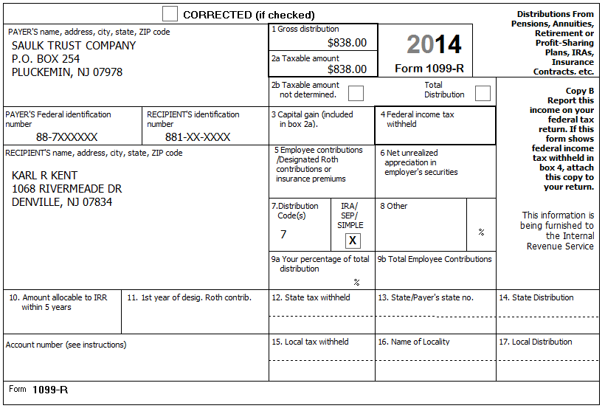
Karl met all his RMD requirement for his IRAs from Saulk Trust account. He has no record of his original contributions.
Reference: 4012 D-20, D-21, D27 C. Example 3
Refund Monitor
AGI | Refund | NJ 39 | NJ 56/66 | Notes
49,213 | 2,503 | 40,843 | 1,723 | Check: NJ 1040 Pg 2, line 19a = 0  BP: Do NJ IRA Wkt now (next sub-step)
Step 12b Source: Notes TWO Screen: NJ IRA Wkt
Reference: NJ Special Handling p7
Refund Monitor
AGI | Refund | NJ 39 | NJ 56/66 | Notes
49,213 | 2,503 | 40,843 | 1,723 | Hint: Set copy number to 1  BP: Have no record of contributions so just make things un-red  Check: NJ 1040, line 19a = 838  Check: NJ 1040, line 27c = 838
Step 13a Source: 1099-R TWO Screen: 1099R
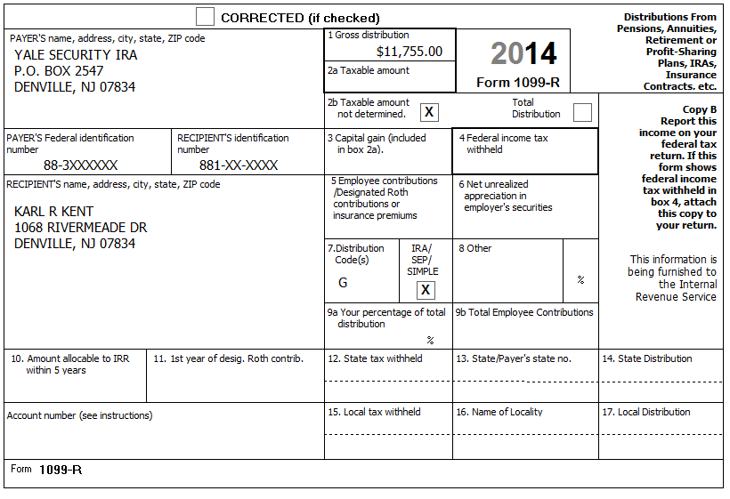
Reference: 4012 D-20, D-22
Refund Monitor
AGI | Refund | NJ 39 | NJ 56/66 | Notes
49,213 | 2,503 | 40,843 | 1,723 | Hint: Use + next to existing 1099R in tree (or Add button above tree, or link from 1040 line 8) to add another 1099R  BP: Do IRA Rollover explanation now
Step 13b Source: Notes TWO Screen: IRA Rollover
Karl did a direct transfer of his traditional IRA funds from Yale Security IRA to Merrill Lynch.
Reference: 4012 D-23
Refund Monitor
AGI | Refund | NJ 39 | NJ 56/66 | Notes
49,213 | 2,503 | 40,843 | 1,723 | Hint: Add IRA Rollover worksheet from 1040, line 15b checkbox (Cannot use Add button above tree)  BP: Include From, To, and Amount in explanation

Step 13c Source: Notes TWO Screen: NJ IRA Wkt
Reference: NJ Special Handling p7
Refund Monitor
AGI | Refund | NJ 39 | NJ 56/66 | Notes
49,213 | 2,503 | 40,843 | 1,723 | Hint: Add new NJ IRA Wkt and set copy number to 2  BP: This is a rollover (code G), so just make things un-red  Check: NJ 1040, line 19a = 838  Check: NJ 1040, line 27c = 838
Step 14 Source: 1099-R TWO Screen: 1099R
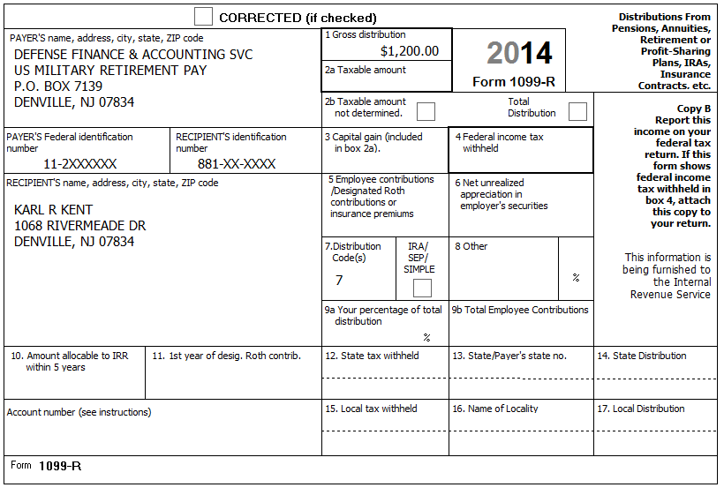
Reference: 4012 D-20, D-21, D-27 A. Example 1
Reference: NJ Special Handling p 2
Refund Monitor
AGI | Refund | NJ 39 | NJ 56/66 | Notes
50,413 | 2,383 | 40,843 | 1,723 | Hint: See NJ Special Handling for Military Pensions  Hint: Can make red boxes un-red – box 1 amount will be used for taxable amount (federal)  Check: NJ 1040, line 19a = 838
Step 15a Source: 1099-R TWO Screen: 1099R
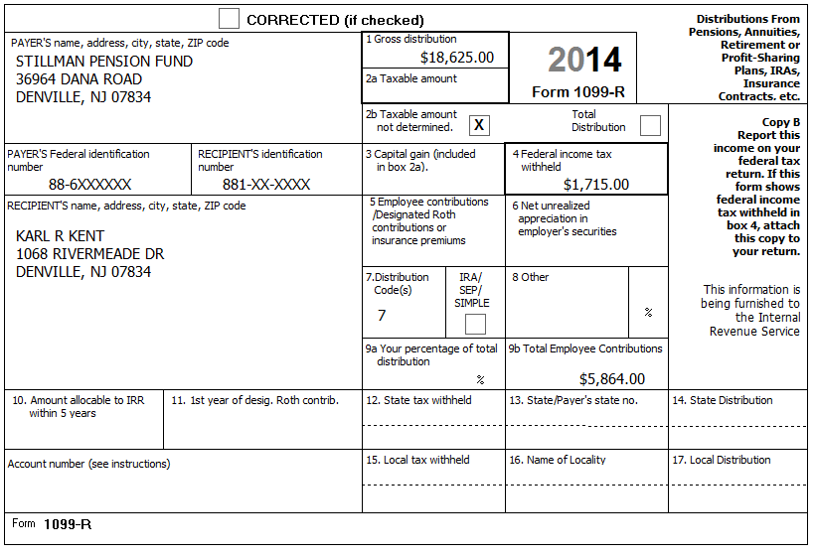
Karl retired two years ago and started drawing his retirement pay from Stillman on January 1, 2013. He recovered $335 of his cost during the first year. Karl did not select a joint and survivor annuity.
Reference: 4012 D-20, D-21, D-24, D-27 B. Example 2
Reference: NJ Special Handling p2
Tool: Annuity Calculator (link on Preparer page)
Refund Monitor
AGI | Refund | NJ 39 | NJ 56/66 | Notes
68,703 | 1,415 | 40,843 | 1,723 | Hint: Box 2 blank and amount in box 9b, so use Simplified Method section of 1099R worksheet to calculate exclusion (non-taxable) amount  Hint: Annuity Calculator tool helpful for filling Simplified Method section  Hint: Don’t forget to put prior year amount on line 5 of Simplified Method section  Check: NJ 1040, line 19a = 19,128  BP: Make adjustment on NJ 1040, line 19b now (next sub-step)

Step 15b Source: 1099R Simplified Method TWO Screen: Scratch Pad*
* Scratch Pad attached to NJ 1040 Pg 2, Line 19b
Reference: NJ Special Handling p5
Refund Monitor
AGI | Refund | NJ 39 | NJ 56/66 | Notes
68,703 | 1,415 | 40,843 | 1,723 | Hint: Follow procedure in NJ Special Handling, p5 for NJ 1040 Pg 2, Line 19b (Excludable pensions)  Check: NJ 1040, line 19b = 335  Check: NJ 1040, line 19a (19,128) + line 19b (335) = 19,463 and  Saulk box 1 (838) + Stillman box 1 (18,625) = 19,463

Step 16 Source: K-1 TWO Screen: Sch E
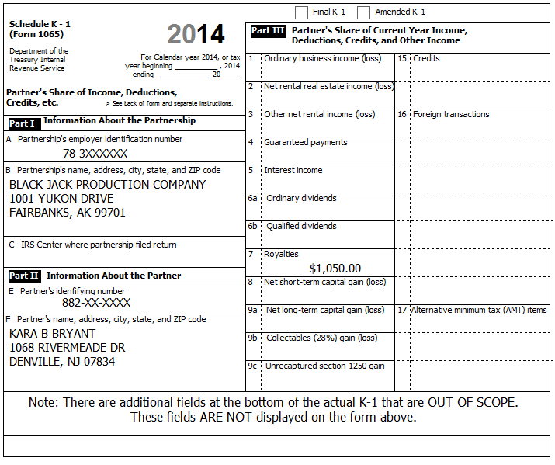
Reference: Special Topic Document – K-1 Income Entry
Refund Monitor
AGI | Refund | NJ 39 | NJ 56/66 | Notes
69,753 | 1,257 | 41,893 | 1,704 | Hint: Need to manually add Sch E to tree  Hint: Do NOT use K-1 form in TW !
Step 17 Source: 1099-G TWO Screen: 1099G Wkt
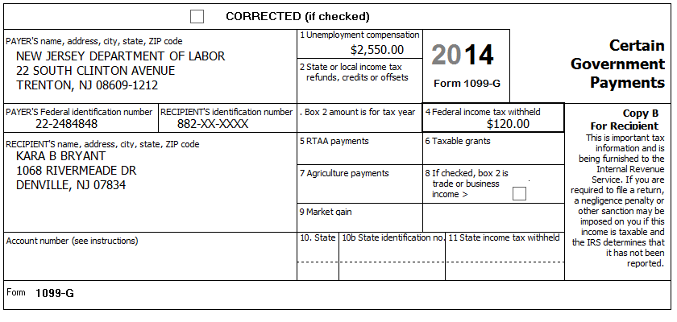
Kara said she received some unemployment, but didn’t receive any paperwork from the state. (NJ no longer sends out paper 1099-G forms for unemployment.) Luckily, Kara has her User ID and Password so you can help get a copy of her 1099-G online.
Reference: NJ Form 1099G Inquiry (Unemployment) (link on Preparer page)
Refund Monitor
AGI | Refund | NJ 39 | NJ 56/66 | Notes
72,303 | 995 | 41,893 | 1,704 | Hint: 1099G Wkt probably already in tree with NJ info filled in
Step 18 Source: SSA-1099 TWO Screen: 1040 Wkt1
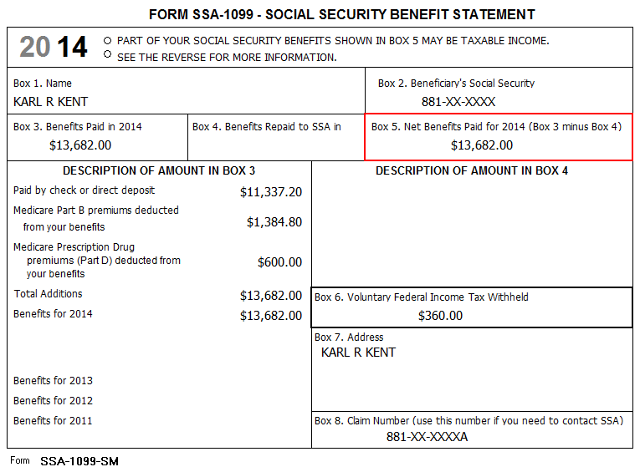
[no notes]
Reference: 4012 D-26
Refund Monitor
AGI | Refund | NJ 39 | NJ 56/66 | Notes
83,933 | (393) | 40,916 | 1,721 | Hint: Enter Social security received and Federal tax withheld, then add Scratch Pad for Medicare  BP: Use Scratch Pad linked to “Medicare Parts B, C, and D to Schedule A” row, Taxpayer column to document breakdown of Medicare premiums if more than one of Part B, C, D  Check: A Detail, Medicare from 1040 worksheet box = 1,985
Step 19 Source: W2-G TWO Screen: W2G
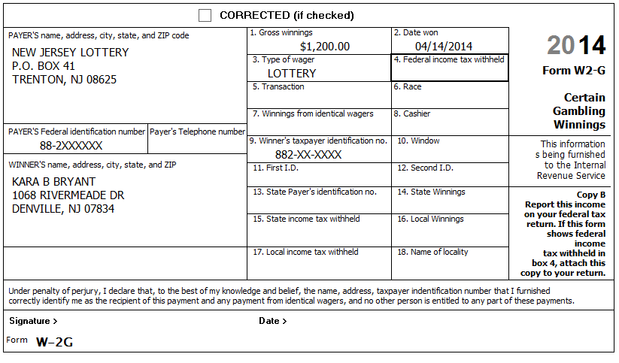
Kara had $600 in losses on Lottery tickets and $400 in losses on slot machines.
Reference: NJ Special Handling p3
Refund Monitor
AGI | Refund | NJ 39 | NJ 56/66 | Notes
85,133 | (573) | 40,916 | 1,721 | Hint: Need to add W2G (if not in tree)  BP: Include appropriate losses directly on W2G (bottom right)  Check: Sch A, line 28 = 1,000
Step 20a Source: 1099-C TWO Screen: 1040 Wkt7
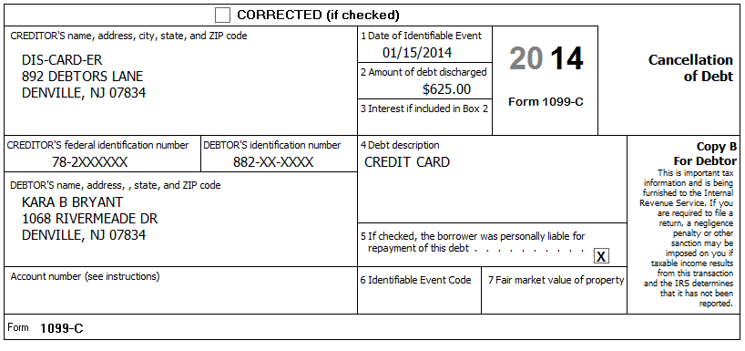
Kara was able to negotiate a deal with an overdue credit card to reduce her amount owed. The card was only used for personal expenses. She was solvent at the time and has never been involved in any bankruptcy proceedings.
Reference: 4012 D-33
Reference: NJ Special Handling p3
Reference: Special Topic: Cancellation of Debt – Credit Card
Refund Monitor
AGI | Refund | NJ 39 | NJ 56/66 | Notes
85,758 | (663) | 41,553 | 1,709 | Hint: 1040 Wkt7 should have been automatically added in previous step  BP: NJ Other Inc will be automatically added to tree - Handle reversing entry now (next sub-step)
Step 20b Source: Notes TWO Screen: NJ Other Inc
[no Notes]
Reference: NJ Special Handling p5
Reference: Special Topic: Cancellation of Debt – Credit Card
Refund Monitor
AGI | Refund | NJ 39 | NJ 56/66 | Notes
85,758 | (663) | 40,916 | 1,721 | Hint: NJ Other Inc should already be in tree

Step 21 Source: Notes TWO Screen: 1040 Wkt2
Kara bought her classroom supplies for her sixth graders and has receipts totaling $240.00. Kara worked over 1,000 hours and her costs were not reimbursed.
Reference: 4012 EXT-1
Refund Monitor
AGI | Refund | NJ 39 | NJ 56/66 | Notes
85,518 | (625) | 40,916 | 1,721 | Hint: Need to add 1040 Wkt2 if not already in tree
Step 22 Source: Notes TWO Screen: 1040 Pg 1
Karl paid $3,600 in alimony to a previous wife. The previous wife’s social security number is 886-XX-XXXX.
Reference: 4012 E-3, E-5
Refund Monitor
AGI | Refund | NJ 39 | NJ 56/66 | Notes
81,918 | (85) | 37,316 | 1,784 | Hint: One of the very few entries directly on 1040
Step 23 Source: Notes TWO Screen: IRA Wkt
Kara made a contribution of $3,000 to her traditional IRA account and another $3,000 to her Roth IRA account.
Reference: 4012 E-3, E-5
Refund Monitor
AGI | Refund | NJ 39 | NJ 56/66 | Notes
78,918 | 365 | 37,316 | 1,784 | Hint: Will need to add IRA Wkt to tree
Step 24 Source: Notes TWO Screen: 1040 Wkt2
Kara’s brother, Kaleb, paid $268 interest on a student loan Kara incurred to obtain her teaching degree.
Reference: 4012 E-4, E-5
Refund Monitor
AGI | Refund | NJ 39 | NJ 56/66 | Notes
78,650 | 402 | 37,316 | 1,784 | Hint: 1040 Wkt2 should already be in tree

Step 25 Source: Notes TWO Screen: [see sub-steps]
The Kents brought a list of items they would like to deduct on their return.
Itemized Deduction List
Long Term Care insurance (Kara) $4,000
Doctor bills $1,653
Hospital bills $3,200
Life insurance $1,842
Funeral expenses $5,600
Medical mileage 103 miles per month (1,236 miles total)
Prescription drugs $965
Prescription eyeglasses $210
Church cash donations with canceled checks $1,650
Cash contributions to: National Public Radio, American Cancer Society,
Shriners Children’s Hospital with canceled checks and receipts $225
Contributions to Millsap Elementary School with canceled checks and receipts $250
Salvation Army (FMV of clothes and TV in good used condition;
Kents have receipts for these contributions.) $350
Sales Tax on a new car $1,400
Home mortgage interest (Form 1098) $3,164
Real estate tax (Principal residence) $7,135
Real estate tax (Empty lot in Georgia) $245
Gambling losses (Lottery) $600
Gambling losses (Slots) $400
Speeding tickets $375
Note: We will see later that the Kents participate in the NJ PTR program, we are going to ignore this for now to be consistent with the order of topics in the NJTL Training decks.
Step 25a Source: Notes TWO Screen: Sch A
[see Itemized Deduction List, above]
Reference: 4012 F-3 thru F-6
Reference: NJ Special Handling p4, p8
Refund Monitor
AGI | Refund | NJ 39 | NJ 56/66 | Notes
78,650 | 492 | 37,316 | 1,784 | Hint: Enter only items which go directly on Sch A now, other items will be entered in other sub-step(s)  Hint: Some items in list may not be deductible or may have already been entered  Hint: Remember that we are ignoring PTR complications for now…  BP: Use Scratch Pad linked from Line 6, 4th box to document source of non-principal residence real estate tax amount  BP: Enter Real estate tax on NJ 1040 Pg 3 now (next sub-step)
Step 25b Source: Notes TWO Screen: NJ 1040 Pg 3, Worksheet F
The Kents qualified for the NJ PTR program last year. Their base year tax amount is $6,802.
Reference: NJ Special Handling p12
Refund Monitor
AGI | Refund | NJ 39 | NJ 56/66 | Notes
78,650 | 492 | 30,514 | 1,903 | Hint: What is correct number to use if TP is in the NJ PTR program?
Step 25c Source: Notes TWO Screen: NJ 1040 Pg 3, Line 37
According to the postcard from the tax office: – Block=50001, Lot-00002, Qualifier is blank.
Reference: NJ Special Handling p6
Refund Monitor
AGI | Refund | NJ 39 | NJ 56/66 | Notes
78,650 | 492 | 30,514 | 1,903 | BP: Correct amount reported on line 37a via a Scratch Pad attached to line 37a  Hint: In this case, County / municipality code is same as on NJ 1040 Pg1  Hint: Read NJ Special Handling for how to handle 37c checkbox
Step 25d Source: Notes TWO Screen: A Detail
[see Itemized Deduction List, above]
Reference: 4012 F-7
Refund Monitor
AGI | Refund | NJ 39 | NJ 56/66 | Notes
78,650 | 1,782 | 20,196 | 2,084 | Hint: Enter only items which go directly on A Detail worksheet now, other items will be entered in other sub-step(s)  Hint: Some items in list may not be deductible or may have already been entered  Check: Sch A, Line 1 = 12,023; Line 19 = 2,475
Step 25e Source: Notes TWO Screen: Sales Tax
[see Itemized Deduction List, above]
Reference: 4012 n/a
Refund Monitor
AGI | Refund | NJ 39 | NJ 56/66 | Notes
78,650 | 1,782 | 20,196 | 2,084 | Hint: Enter only items which go directly on Sales Tax worksheet now, other items will be entered in other sub-step(s)  Hint: Some items in list may not be deductible or may have already been entered  BP: Use Scratch Pad linked to line 8 to document source of amount  Check: Sch A, line 5b = 2,420
Step 26 Source: Notes TWO Screen: 5695 Pg 2
The Kents insulated the crawl space of their home for $175.00 and replaced all their windows with new windows meeting the IECC criteria (energy efficiency) at a cost of $7,450.00 excluding onsite preparation, assembly, or original installation of components.
Looking at last year’s return, you see that the Kents had $305 of Nonbusiness energy property credit (Form 5695, line 30). They had no energy credits for years before last year.
Reference: 4012 EXT-4
Refund Monitor
AGI | Refund | NJ 39 | NJ 56/66 | Notes
78,650 | 1,977 | 20,196 | 2,084 | Hint: Need to add Form 5695 to the tree
Step 27 Source: Notes TWO Screen: 2441 Pg 1
Karl and Kara paid the Maryville Day Care Center $1,100 to watch Dave while they worked. The address is 128 Menio St, Denville, NJ 07834. The EIN for the center is 88-0XXXXXX.
Reference: 4012 G-3 thru G-5
Refund Monitor
AGI | Refund | NJ 39 | NJ 56/66 | Notes
78,650 | 2,197 | 20,196 | 2,084 | Hint: Form 2441 is already in tree (because checked DC box for David on Main Info)
Step 28 Source: Notes TWO Screen: F/S Tax Pd
Karl and Kara applied $200 from last year’s federal tax refund and $100 from last year’s state tax refund toward this year’s federal and state taxes.
During the year, Karl and Kara made the following estimated tax payments:
Date | Federal | NJ
04-14 | $100 | $50
09-15 | $100 | $40

Reference: 4012 H-3
Reference: NJ Special Handling p11
Refund Monitor
AGI | Refund | NJ 39 | NJ 56/66 | Notes
78,650 | 2,627 | 20,196 | 2,274 | Hint: F/S Tax Pd is already in tree (below W-2s)  Hint: If any quarterly amount boxes with zero are red, just make them un-red  Hint: Un-red the “NJ state and/or local balance due from previous years’ returns…” box (if red)  Check: Sch A, line 5a = 2,846

Step 29 Source: Notes TWO Screen:
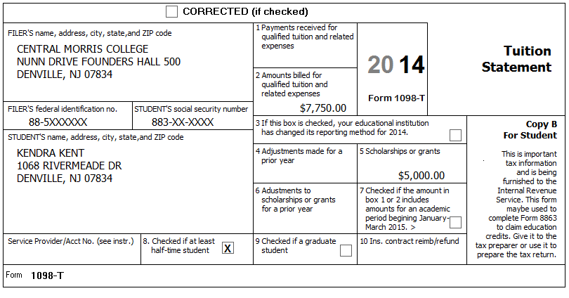
Kara and Karl paid $2,750 for Kendra’s tuition plus an additional $3,500 for room and board. Kendra spent $500.00 on textbooks and supplies (which were not an enrollment requirement) and $850.00 for a new computer (which was not a course requirement). Kendra did not receive a 1098-T for 2013. This is Kendra’s third year in (undergraduate) college. Kendra has no felony convictions of any kind.
Kara had to take several special training courses at Boonton College that were required by her employer. Boonton college address: 123 Main, Boonton, NJ 07005. Kara did not receive a 1098-T nor was she enrolled at least half-time. The class tuition and fees totaled $317.85.
Reference: 4012 J-1 thru J-8, EXT-2
Step 29a Source: Notes TWO Screen: Diagnostics
We are going to compare several alternative ways of handling the Kent’s education costs.
Ordinarily, before doing this, we would take care of any (federal) red forms in the tree and then run Diagnostics to make sure there are no unresolved issues before doing this comparison. Because the Kent problem is so complex, the only (federal) red forms in the tree are 1040 ACA Wkt and Prep Use. We are saving ACA stuff for last for training purposes and Prep Use will always be red before QR, so we only need to run Diagnostics at this point
If Diagnostics shows any Errors, then they need to be fixed before proceeding; Warnings, Overridden Entries, etc. are usually not something to worry about. (Note: If you have an Error, clicking on the Error will (usually, but not always) take you to the form that needs to be fixed.)
Step 29b Source: Notes TWO Screen: 1040 Wkt2
We will try both Kara’s and Kendra’s expenses as a Tuition and Fees AGI Deduction first. (This is least likely to be the best choice.)
Refund Monitor
AGI | Refund | NJ 39 | NJ 56/66 | Notes
75,582 | 3,122 | 20,196 | 2,274 | Hint: The Tuition and Fees as an AGI Deduction section is at the bottom of the worksheet
Step 29bx Source: Notes TWO Screen: 1040 Wkt2
Be sure to remove all testing entries and check that federal AGI/Refund plus NJ numbers return to previous values before proceeding
Refund Monitor
AGI | Refund | NJ 39 | NJ 56/66 | Notes
78,650 | 2,627 | 20,196 | 2,274
Step 29c Source: Notes TWO Screen: 8863 Pg 2
We will try both Kara’s and Kendra’s expenses as a Lifetime Learning Credit next.
Refund Monitor
AGI | Refund | NJ 39 | NJ 56/66 | Notes
78,650 | 3,241 | 20,196 | 2,274 | Hint: Need to add 8863 Pg 2 to tree (Note: not 8863 Pg 1 – 8863 Pg 1 will pop into the tree as soon as start to fill in Pg 2)  Hint: Need to add separate 8863 for each student (i.e. one for Kara and second for Kendra)  Result: Lifetime Learning better than AGI Deduction
Step 29d Source: Notes TWO Screen: 8863 Pg 2
We will try Kara’s expenses as a Lifetime Learning Credit (she doesn’t qualify for American Opportunity Credit) and Kendra’s expenses as an American Opportunity Credit next.
Refund Monitor
AGI | Refund | NJ 39 | NJ 56/66 | Notes
78,650 | 5,004 | 20,196 | 2,274 | Hint: Remove Kendra’s entry from Lifetime Learning section and enter in American Opportunity Credit section  BP: Use Scratch Pad linked to Kendra’s 8863 Pg 2, Line 27 to document breakdown of Kendra’s expenses  Result: American Opportunity Credit best result for TP
Note: ACA would typically be handled at this point
To support training and to allow for alternate ACA situations, handling ACA is deferred to later.
Step 30 Source: Notes TWO Screen: Sch A
The Kents qualified for the NJ PTR program last year and received a rebate of $205
As is recommended, the base year tax amount was used in the step where property tax was entered on NJ 1040 Pg 3, Worksheet F. We are now going to handle the $205 PTR rebate.
Because the Kents itemized last year, the PTR rebate is a recovery.
Reference: NJ Special Handling p4, p9
Refund Monitor
AGI | Refund | NJ 39 | NJ 56/66 | Notes
78,650 | 4,974 | 20,196 | 2,274 | BP: Use Scratch Pad to document PTR adjustment  Hint: There is already a Scratch Pad on the 4th box (from real estate tax on Georgia lot), so just add PTR amount to it
Step 31 Source: Notes TWO Screen: Diagnostics
We should be done with the federal return entry. Before moving on to cleaning up NJ unique items, we should check that there are no unresolved federal issues.
If Diagnostics shows any Errors, then they need to be fixed before proceeding.
Step 32 Source: Notes TWO Screen: NJ 1040 Pg 2, Line 30
Add Karl’s $1,200 pre-tax federal / after-tax NJ Dental Insurance to other medical expenses on NJ 1040, Line 30
Reference: NJ Special Handling p6
Refund Monitor
AGI | Refund | NJ 39 | NJ 56/66 | Notes
78,650 | 4,974 | 18,996 | 2,291 | BP: Use Scratch Pad linked to Line 30 to document source of NJ after-tax medical amount
Step 33 Source: Notes TWO Screen: NJ 1040 Pg 3, Line 45
The Kents would like to use the standard amount suggested by the NJ-1040 Instructions for the amount of Use Tax they owe.
Reference: NJ 1040 Instructions or link to Use Tax table on Preparer page
Refund Monitor
AGI | Refund | NJ 39 | NJ 56/66 | Notes
78,650 | 4,974 | 18,996 | 2,207 | Hint: Use NJ 1040, Line 28 amount to look up estimated amount in chart  BP: Use Scratch Pad linked to Line 45 to document how Use Tax amount was calculated  Hint: Will still need to un-red line 45
Step 34 Source: Notes TWO Screen: Diagnostics
We should be done with the federal and New Jersey return entry. Before moving on to handle their Refund / Amount Due, we should check that there are no unresolved issues.
If Diagnostics shows any Errors, then they need to be fixed before proceeding.
Step 35 Source: Notes TWO Screen:
The Kents said on their Intake Sheet that they wanted direct deposit for any federal refund. You confirm that this is still true and ask about their state refund and they say they would also like to use direct deposit. They show you a blank check from their local US bank so you can get their information.
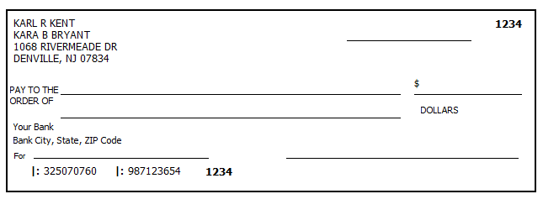
Reference: 4012 K-14
Step 35a Source: Notes TWO Screen: Main Info
[see Notes above]
Refund Monitor
AGI | Refund | NJ 39 | NJ 56/66 | Notes
78,650 | 4,974 | 18,996 | 2,207 | Hint: Enter Routing # (RTN) and Account # (DAN) about 2/3 the way down the Main Info worksheet
Step 35b Source: Notes TWO Screen: 1040 Pg 2, Line 76
[see Notes above]
Refund Monitor
AGI | Refund | NJ 39 | NJ 56/66 | Notes
78,650 | 4,974 | 18,996 | 2,207 | Hint: Enter Routing # (RTN), select Checking, and enter Account # (DAN) on Line 76
Step 35c Source: Notes TWO Screen: NJ DD Wkt
[see Notes above]
Refund Monitor
AGI | Refund | NJ 39 | NJ 56/66 | Notes
78,650 | 4,974 | 18,996 | 2,207 | Hint: Read options under Direct Deposit and select appropriate one  Hint: Will need to answer about foreign bank
Step 36a Source: Notes TWO Screen: Diagnostics
We should be done with the federal and New Jersey return entry. Before wrapping up, we should check that there are no unresolved issues.
If Diagnostics shows any Errors, then they need to be fixed before proceeding.
Step 36b Source: Notes TWO Screen: Diagnostics
When the Diagnostics check is clean, we should click the Create e-File(s) button. This runs an additional level of diagnostic checks and actually creates the e-Files which will be transmitted to CCH and then to the IRS and New Jersey.

Step 37 Source: Notes TWO Screen: 1040 ACA Wkt
Karl and Carmen had Medicare all year.
Kara, Kendra, and Dave had health insurance through Kara’s employer all year.
Note: This step is out of order to allow separation of ACA instruction and to allow for an alternative ACA situation.
Reference: 4012 ACA Tab
Reference: ACA TaxWise Procedures (TY2014 version)

Refund Monitor
AGI | Refund | NJ 39 | NJ 56/66 | Notes
78,650 | 4,974 | 18,996 | 2,207 | Hint: Everyone marked as Full
Step 38 Source: Notes TWO Screen: Diagnostics
Run Diagnostics (and Create e-File) – Resolve any issues (and don’t forget to celebrate finishing the Kent problem!!)
For a client return, the next step would be Quality Review…

